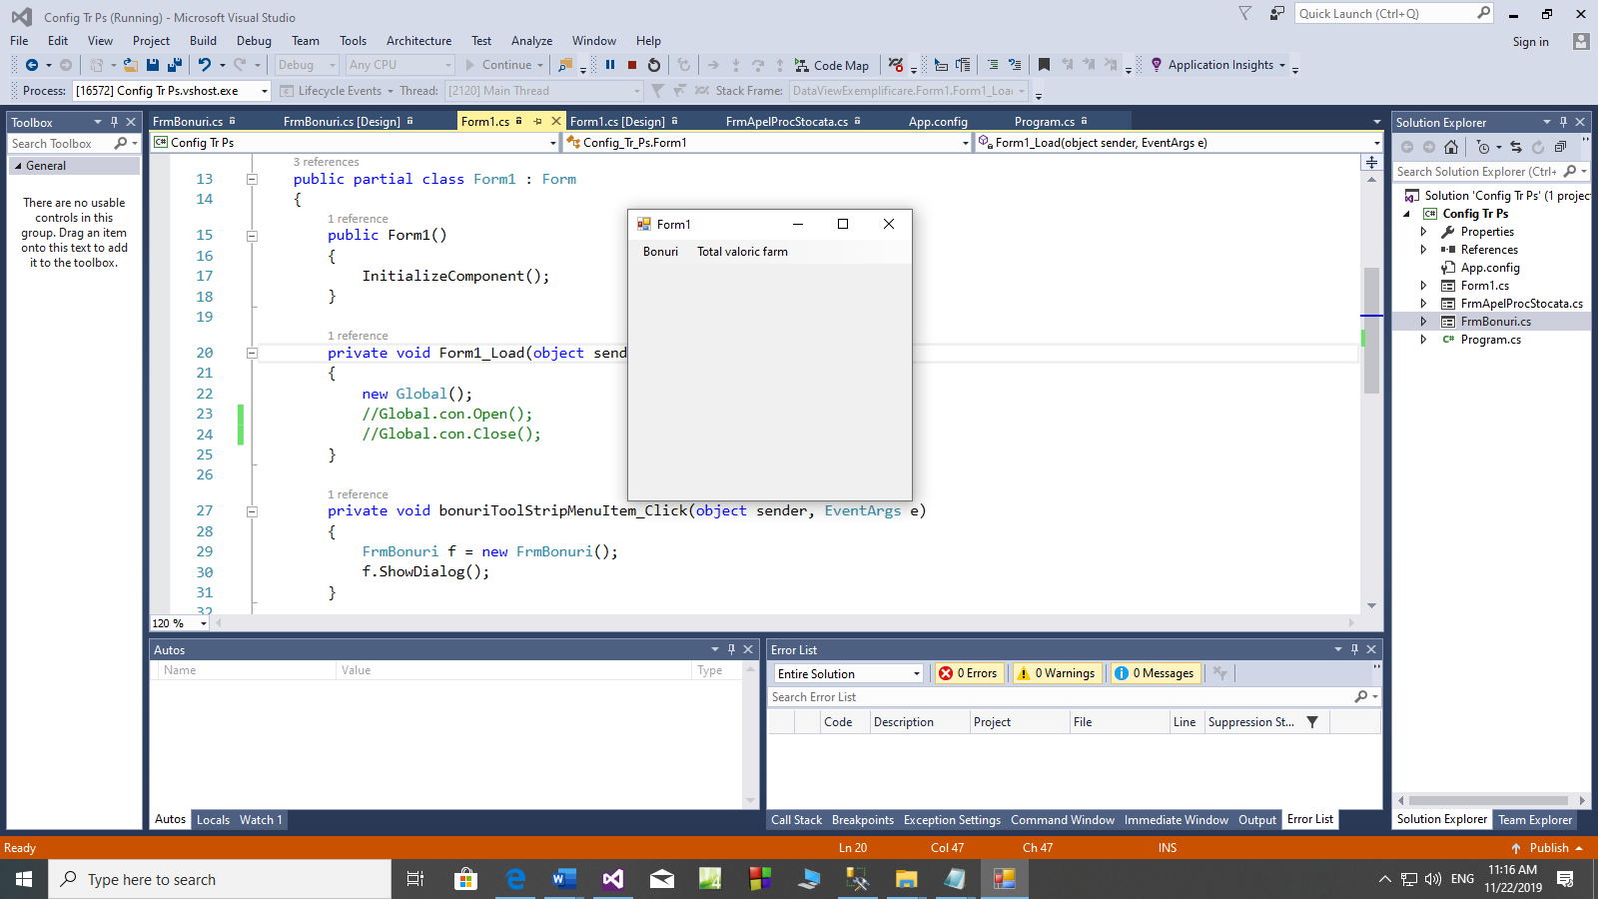

Form2:

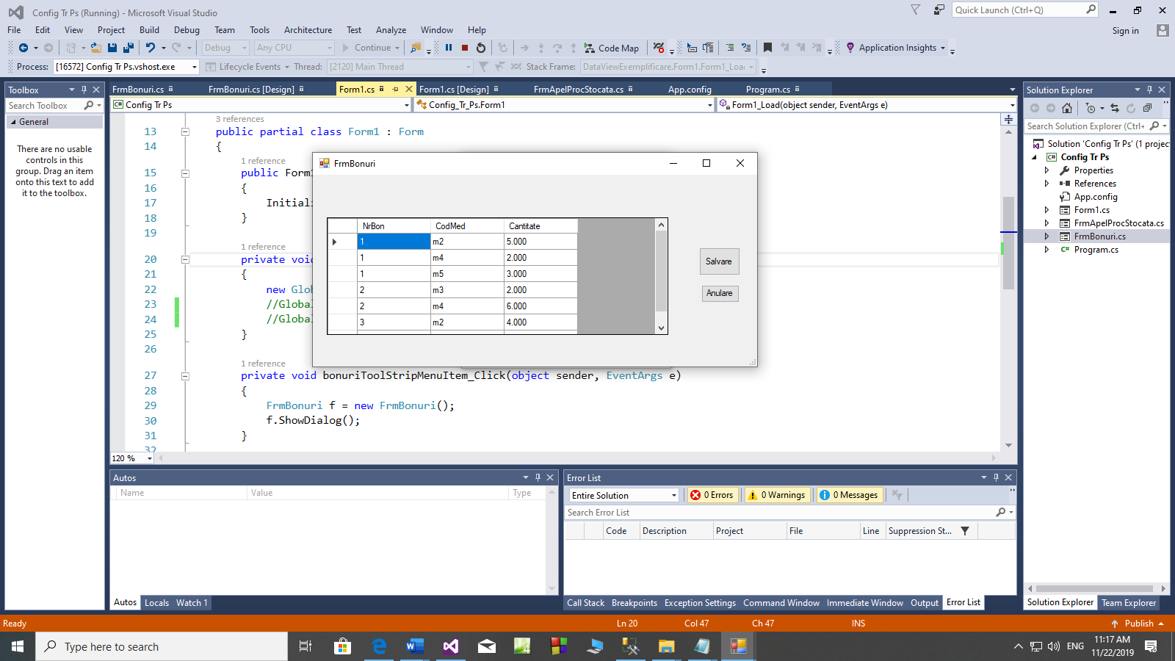

Form 3:

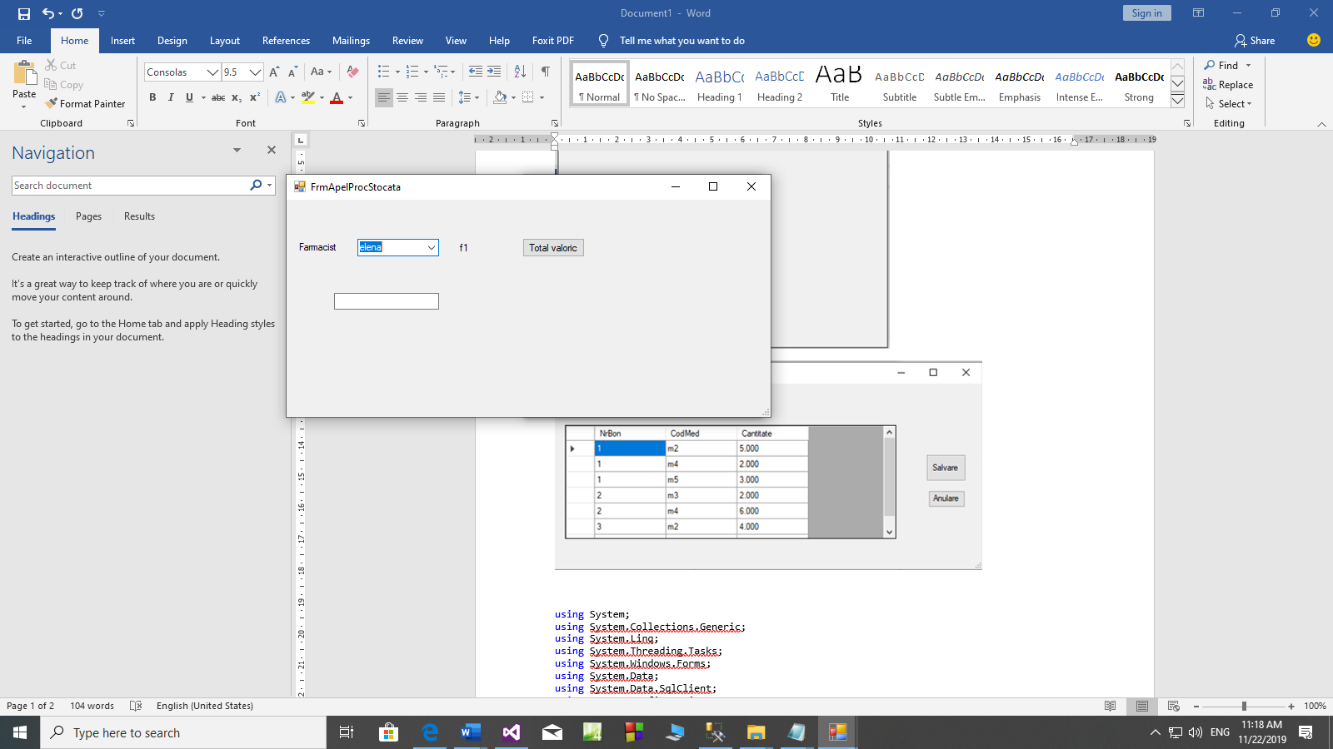

using System;

using System.Collections.Generic;

using System.Data;

using System.Data.SqlClient;

using System.Linq;

using System.Threading.Tasks;

using System.Windows.Forms;

namespace Aplicatie_Tr_PS

{

class Global

{

public static string stringConectare = ""; // de completat

// pp baza de date este realizata in sqlserver

public static SqlConnection con;

public static SqlDataAdapter daBonuri;

public static DataSet ds;

public Global()

{

con = new SqlConnection(stringConectare);

ds = new DataSet();

daBonuri = new SqlDataAdapter("select * from tDetaliiBon", con);

daBonuri.Fill(ds, "Bonuri");

SqlCommandBuilder cb = new SqlCommandBuilder(daBonuri);

daBonuri.InsertCommand = cb.GetInsertCommand();

daBonuri.DeleteCommand = cb.GetDeleteCommand();

daBonuri.UpdateCommand = cb.GetUpdateCommand();

}

}

static class Program

{

/// <summary>

/// The main entry point for the application.

/// </summary>

[STAThread]

static void Main()

{

Application.EnableVisualStyles();

Application.SetCompatibleTextRenderingDefault(false);

Application.Run(new Form1());

}

}

}

using System;

using System.Collections.Generic;

using System.ComponentModel;

using System.Data;

using System.Drawing;

using System.Linq;

using System.Text;

using System.Threading.Tasks;

using System.Windows.Forms;

namespace Aplicatie_Tr_PS

{

public partial class Form1 : Form

{

public Form1()

{

InitializeComponent();

}

private void bonuriToolStripMenuItem_Click(object sender, EventArgs e)

{

Form2 f = new Form2();

f.ShowDialog();

}

private void totalValoricToolStripMenuItem_Click(object sender, EventArgs e)

{

Form3 f = new Form3();

f.ShowDialog();

}

private void Form1_Load(object sender, EventArgs e)

{

new Global();

}

}

}

using System;

using System.Collections.Generic;

using System.ComponentModel;

using System.Data;

using System.Data.SqlClient;

using System.Drawing;

using System.Linq;

using System.Text;

using System.Threading.Tasks;

using System.Windows.Forms;

namespace Aplicatie_Tr_PS

{

public partial class Form2 : Form

{

public Form2()

{

InitializeComponent();

}

private void Form2_Load(object sender, EventArgs e)

{

dataGridView1.DataSource = Global.ds;

dataGridView1.DataMember = "Bonuri";

}

private void bAnulare_Click(object sender, EventArgs e)

{

Global.ds.Tables["Bonuri"].RejectChanges();

}

private void bSalvare_Click(object sender, EventArgs e)

{

Global.con.Open();

SqlTransaction tr = Global.con.BeginTransaction();

Global.daBonuri.InsertCommand.Transaction = tr;

Global.daBonuri.UpdateCommand.Transaction = tr;

Global.daBonuri.DeleteCommand.Transaction = tr;

DataTable t = Global.ds.Tables["Bonuri"].GetChanges();

try

{

if(t!=null)

{

Global.daBonuri.Update(t);

Global.ds.Tables["Bonuri"].AcceptChanges();

tr.Commit();

}

}

catch (Exception ex)

{

MessageBox.Show("Salvare anulata\n" + ex);

tr.Rollback();

}

finally

{

Global.con.Close();

}

}

}

}

using System;

using System.Collections.Generic;

using System.ComponentModel;

using System.Data;

using System.Data.SqlClient;

using System.Drawing;

using System.Linq;

using System.Text;

using System.Threading.Tasks;

using System.Windows.Forms;

namespace Aplicatie_Tr_PS

{

public partial class Form3 : Form

{

public Form3()

{

InitializeComponent();

}

private void Form3_Load(object sender, EventArgs e)

{

SqlDataAdapter daFarm = new SqlDataAdapter("select codFarm, Nume from tFarmacisti", Global.con);

daFarm.Fill(Global.ds, "Farmacisti");

DataView dv = new DataView(Global.ds.Tables["Farmacisti"]);

dv.Sort = "Nume";

cbFarmacist.DataSource = dv;

cbFarmacist.DisplayMember = "nume";

cbFarmacist.ValueMember = "CodFarm";

lFarmacist.Text = cbFarmacist.SelectedValue.ToString();

}

private void cbFarmacist_SelectedIndexChanged(object sender, EventArgs e)

{

lFarmacist.Text = cbFarmacist.SelectedValue.ToString();

}

private void bTotal_Click(object sender, EventArgs e)

{

SqlCommand cmd = new SqlCommand();

cmd.Connection = Global.con;

cmd.CommandType = CommandType.StoredProcedure;

cmd.CommandText = "ps_ValBonFarm"; // aceasta procedura trebuie creata in sqlserver

SqlParameter p1 = new SqlParameter();

p1.Value = lFarmacist.Text;

p1.ParameterName = "@CodFarm";

cmd.Parameters.Add(p1);

SqlParameter p2 = new SqlParameter();

p2.ParameterName = "@Total";

p2.DbType = DbType.Decimal;

p2.Direction = ParameterDirection.Output;

cmd.Parameters.Add(p2);

Global.con.Open();

//executarea procedurii

cmd.ExecuteScalar();

tbTotal.Text = p2.Value.ToString();

Global.con.Close();

}}}